Internal Testing

**Home Page:**

1. Menu Bar



Employers and Candidates, should have sub menu, refer below example (<https://www.optnation.com/>)

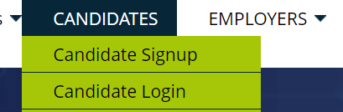

1. Remove login, resister link from top Menu, bring to sub menu of candidate and employer
2. 
3. Search when uer type some word then it should show jobs , same for location. Can refer (<https://www.optnation.com/>)
4. Code can Comment “Explore Categories” section, it should not visible any body now
5. 

Most search should like Java , C# , Testing , Big Data

1. Featured Jobs -> change to Recent Jobs
2. 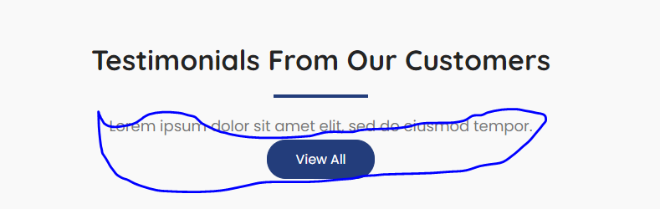

Removed View ALL button and above test message

1. 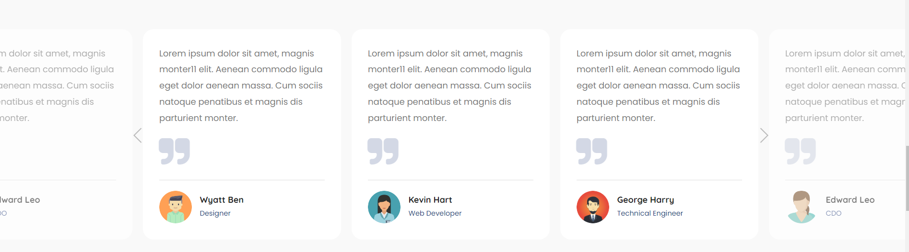

Testimonials only show 3 at time like latest News

1. 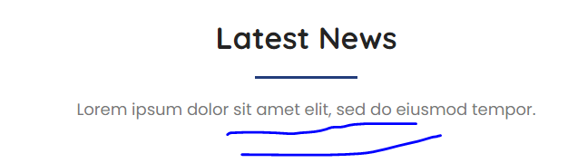

Remove able highlight test message